**TRIBHUVAN UNIVERSITY**

**INSTITUTE OF ENGINEERING**

**Lab Sheet #6**

**PURWANCHAL CAMPUS**

DHARAN-8

**Submitted by:** **Submitted to:**

Name: **Arbind Kumar Mehta** Department of

Roll No: **PUR075BCT017** Electronics & Computer

Faculty: BCT Engineering

Group: I/I ‘A’

Date: ….......................... Checked by: ……………………….

**Title:**

Write a program to find sum as Y of the following series excluding prime number in the series. (Write function program to check whether the number is prime or not. also write recursive function to calculate the factorial of the series numbers).

Y = 1 +1/ 1!+22/ 2!+32 /3!+ ⋯+ 102/10!

**Objective:**

* To understand the programming using Loop & nested loop Statements (for, while, do-while)

**Problem Analysis:**

Based on problem, it is required to define three integer variable and a float variable. Different operation should performed using user defined function.

|  |  |  |
| --- | --- | --- |
| **Input variables** | **Output variables** | **Necessary header files/functions/macros** |
| n,i(int type) | Y(float type) | stdio.h  coino.h  scanf()  printf()  math.h  isprime()  fact() |

**Algorithm:**

1. Start
2. Define variables: n,i,Y

for(i=1;i<=10;i++)

{

if(isprime(i)==0)

{

Y=Y+(pow(i,2)/fact(i));

}

}

1. Print:Y
2. Stop

**Flowchart:**

Start

Define variable: i=1,Y

If(i<10)

If(isprime=0)

Y=Y+(pow(i,2)/fact(i)); i++

Print:Y

End

**Code:**

#include <stdio.h>

#include <stdlib.h>

#include <math.h>

int fact(int n)

{

if(n==1||n==0)

return 1;

else

return(n*fact(n-1));

}

int isprime(int n)

{

int i,flag=0;

for(i=2;i<=n/2;i++)

{

if(n%i==0)

flag=1;

}

if(flag==1||n==1||n==2)

return 0;

else

return 1;

}

int main()

{

int n,i;

float Y=1.00;

for(i=1;i<=10;i++)

{

if(isprime(i)==0)

{

Y=Y+(pow(i,2)/fact(i));

}

}

printf("Y=%.3f",Y);

return 0;

}

**Output (Compilation, Debugging and Testing):**

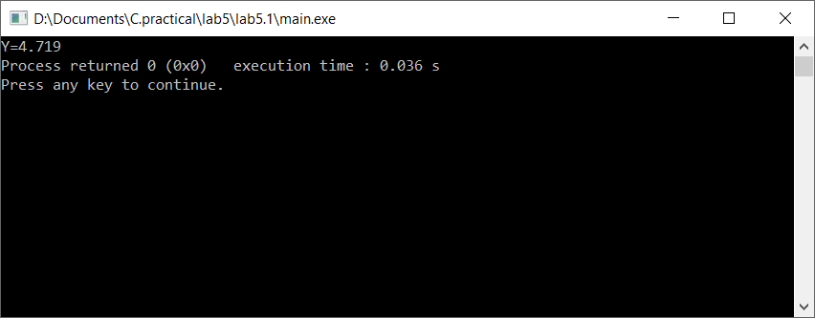

**Discussion & Conclusion:**

In this lab of C programming, based on the focused objective(s) to understand about C data types with formatted input/output functions with user defined functions.

**Title:**

Write a program to add, subtract, multiply and divide two integers using user defined type function with return type.

**Objective:**

* To understand the programming using Loop & nested loop Statements (for, while, do-while) and to be familier with function in C.

**Problem Analysis:**

Based on problem, it is required to define two integer variable and functions. Different operation should performed using if statement and for loop and functions.

|  |  |
| --- | --- |
| **Input variables** | **Necessary header files/functions/macros** |
| n1,n2(int type) | stdio.h  coino.h  scanf()  printf()  add(n1,n2)  sub(n1,n2)  div(n1,n2)  mult(n1,n2) |

**Algorithm:**

1. Start
2. Define : n1,n2, add(n1,n2),sub(n1,n2),div(n1,n2),mult(n1,n2).
3. Read n1,n2
4. add(n1,n2)
5. sub(n1,n2)
6. div(n1,n2)
7. mult(n1,n2)
8. print: values
9. Stop

**Flowchart:**

Start

Define:n1,n2,add(n1,n2)sub(n1,n2)div(n1,n2)

mult(n1,n2)

A

A

Read: n1,n2

add(n1,n2)sub(n1,n2)div(n1,n2)mult(n1,n2)

Print:add(n1,n2)sub(n1,n2)

div(n1,n2)mult(n1,n2)

End

**Code:**

#include <stdio.h>

#include <stdlib.h>

int add(int n1, int n2)

{

return(n1+n2);

}

int sub(int n1,int n2)

{

return(n1-n2);

}

float div1(int n1, int n2)

{

return((float)n1/n2);

}

int mult(int n1, int n2)

{

return(n1*n2);

}

int main()

{

int n1,n2;

printf("Enter two numbers:\n");

scanf("%d\t%d",&n1,&n2);

printf("Sum is:%d\n",add(n1,n2));

printf("Difference is:%d\n",sub(n1,n2));

printf("Product is:%d\n",mult(n1,n2));

printf("Quotient is:%.2f\n",div1(n1,n2));

getch();

return 0;

}

**Output (Compilation, Debugging and Testing):**

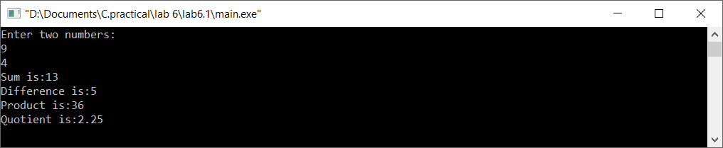

**Discussion & Conclusion:**

In this lab of C programming, based on the focused objective(s) to understand functions in C.

**Title:**

Write a program to calculate sum of first 50 natural numbers using recursive function.

**Objective:**

* To understand the use of recursive functions and if statement in C.

**Problem Analysis:**

Based on problem, it is required to define one integer variable and a function to calculate sum of 50 natural .

|  |  |
| --- | --- |
| **Input variables** | **Necessary header files/functions/macros** |
| n=50(int type) | stdio.h  coino.h  scanf()  printf()  n_sum(int n) |

**Algorithm:**

1. Start
2. Define variables: n=50.
3. Print:n_sum(n)
4. Stop

**Flowchart:**

Start

Define variable: n=50,n_sum(int n)

Print:n_sum(n)

End

**Code:**

#include <stdio.h>

#include <stdlib.h>

int n_sum(int n)

{

if(n==0)

return 0;

else

return(n+n_sum(n-1));

}

int main()

{

int n=50;

printf("The sum of first 50 natural number is:%d\n",n_sum(n));

getch();

return 0;

}

**Output (Compilation, Debugging and Testing):**



**Discussion & Conclusion:**

In this lab of C programming, based on the focused objective(s) to understand use of functions in C.

**Title:**

Define a function named fact() to calculate factorial of a number n and then write a program that uses this function fact() to calculate combination and permutation. **Objective:**

* To understand the programming using functions and if statement in C.

**Problem Analysis:**

Based on problem, it is required to define two integer variable and a functions to return factorial of its integer argument. Different operation should performed using if statement.

|  |  |
| --- | --- |
| **Input variables** | **Necessary header files/functions/macros** |
| n,r(int type) | stdio.h  coino.h  scanf()  printf()  fact(int n) |

**Algorithm:**

1. Start
2. Define variables: n,r.

fact(n);

Print:fact(n), (float)(fact(n)/fact(n-r)), (fact(n)/(fact(n-r)*fact(r)))

1. Stop

**Flowchart:**

Start

Define variable: n,r,fact(n)

Print:fact(n),(float)(fact(/fact(n-r)), (fact(n)/(fact(n-r)*fact(r)))

End

**Code:**

#include <stdio.h>

#include <stdlib.h>

long fact(int n)

{

if(n==0||n==1)

return 1;

else

return(n*fact(n-1));

}

int main()

{

int n,r;

printf("Enter the value of n and r:\n");

scanf("%d\t%d",&n,&r);

printf("Factorial of %d is:%d\n",n,fact(n));

printf("Permutation (%d,%d) is:%.3f\n",n,r,(float)(fact(n)/fact(n-r)));

printf("Combination (%d,%d) is:%.3f\n",n,r,(float)(fact(n)/(fact(n-r)*fact(r))));

getch();

return 0;

}

**Output (Compilation, Debugging and Testing):**

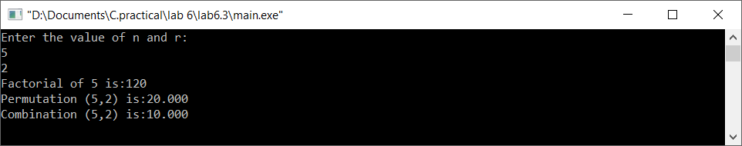

**Discussion & Conclusion:**

In this lab of C programming, based on the focused objective(s) to understand use of functions and if statement in C.

**Title:**

Write a recursive function to generate Fibonacci series.

**Objective:**

* To understand the programming using functions and if statement in C.

**Problem Analysis:**

Based on problem, it is required to define two integer variable. Different operation should performed using if statement and for loop.

|  |  |
| --- | --- |
| **Input variables** | **Necessary header files/functions/macros** |
| i,n(int type) | stdio.h  coino.h  printf()  fibs(int n) |

**Algorithm:**

1. Start
2. Define variables: i,n

for(i=0;i<=n;i++)

{

fibs(i)

}

Print:fibs()

1. Stop

**Flowchart:**

Start

Define variable: n,i

If(i<n)

fibs(i);i++

Print:fibs()

End

**Code:**

#include <stdio.h>

#include <stdlib.h>

int fibs(int n)

{

if(n==0)

return 0;

else if(n==1)

return 1;

else

return(fibs(n-1)+fibs(n-2));

}

int main()

{

int n,i;

printf("Enter the value of n:");

scanf("%d",&n);

for(i=0;i<n;i++)

{

printf("%d ",fibs(i));

}

getch();

return 0;

}

**Output (Compilation, Debugging and Testing):**



**Discussion & Conclusion:**

In this lab of C programming, based on the focused objective(s) to understand about C data types with use functions and if statement and for loop.

**Title:**

Write a program that illustrates use of local, global and static variables

**Objective:**

* To understand the types and uses of different variables in in C.

**Problem Analysis:**

Based on problem, it is required to perform different operation to understand types and uses of different variables in C.

**Code:**

#include <stdio.h>

#include <stdlib.h>

#define a 50 //global variable

int n_sum(int n)

{

if(n==0) //Here n is local variable for this function

return 0;

else

return(n+n_sum(n-1));

}

void sum()

{

here :

printf("The sum is: %d\n",increment());

if(increment()>=5)

exit(1);

goto here;

}

int increment()

{

static int sum=0; //this is static variable

sum++;

return(sum);

}

int main()

{

//here is also local variables

printf("The sum of first 50 natural number is:%d\n",n_sum(a));

getch();

sum();

return 0;

}

**Output (Compilation, Debugging and Testing):**

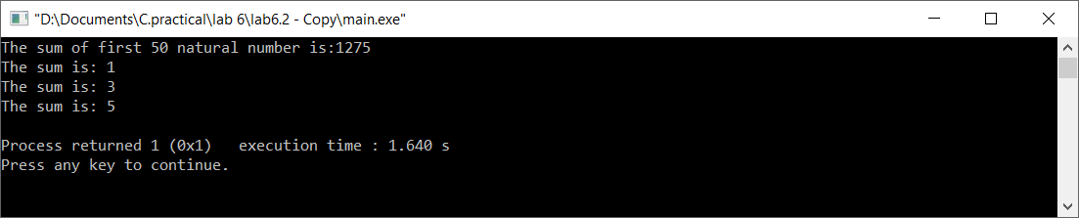

**Discussion & Conclusion:**

In this lab of C programming, based on the focused objective(s) to understand types and uses of different types of variables in C.

***